Updated features on ER System, photo below is the instruction on how to work with it.

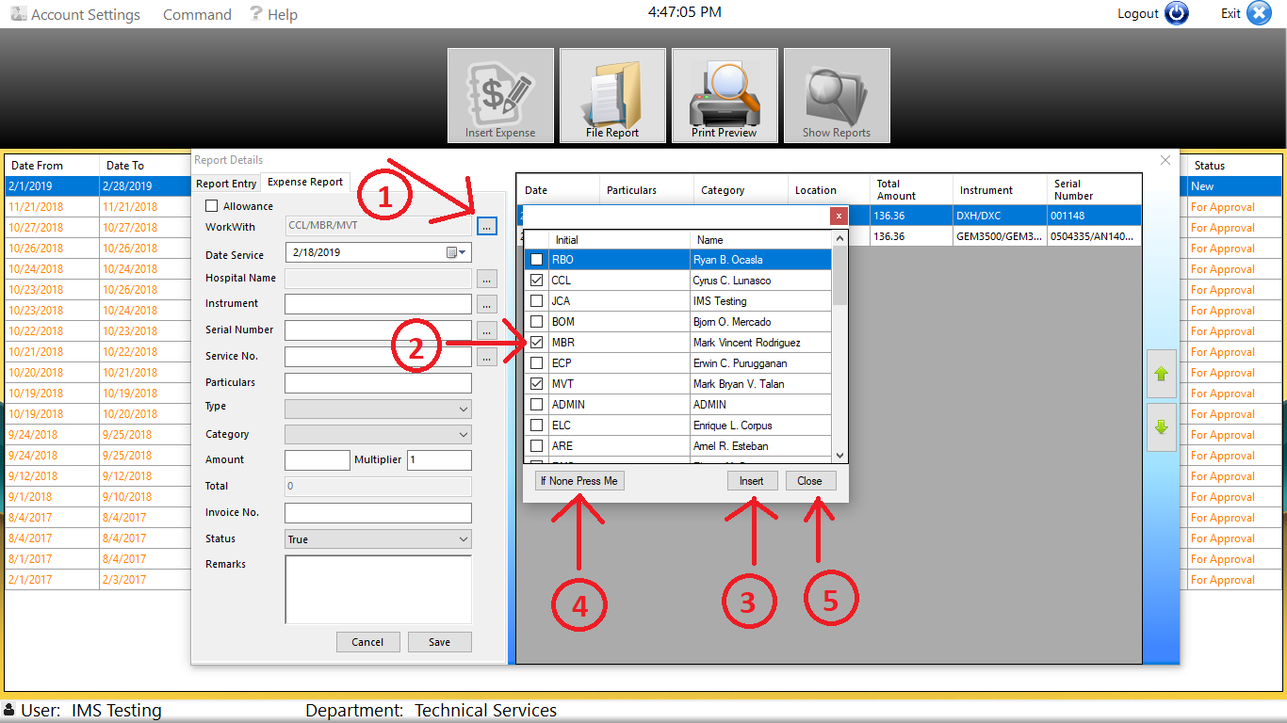

1.0

On our previous version of ER System “WorkWith” will pop-up after you enter the necessary information and clicked the “save” button, and will asked you to enter who/s you work with during that time.

- To choose “WorkWith,” click the three (3) dotted button shown in the photo above (1), list of initials will pop-up

- You can “check” the checkbox to “select” the initials from the given choices, Multiple selection is allowed

- Hit the “insert” button to finalize the selection

- If you work on by yourselves, kindly click “If None Press Me” button
Note: If the initial/s the you are looking for is not included on the choices please contact IMS Personnel.

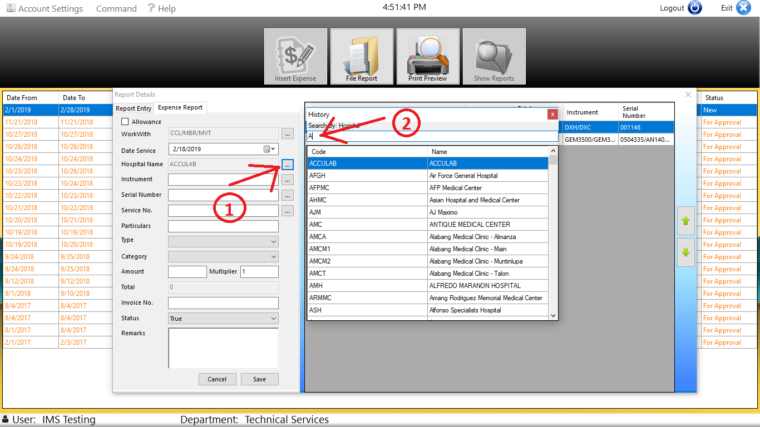

2.0

Hospital Name

- To choose “Hospital Name” click three (3) dotted button, shown in the photo above (1), list of hospital name will pop-up

- Enter hospital code/hospital name and list of hospital names will show, double click to select

Note: If the hospital name that you are looking for is not included on the history please contact IMS personnel.

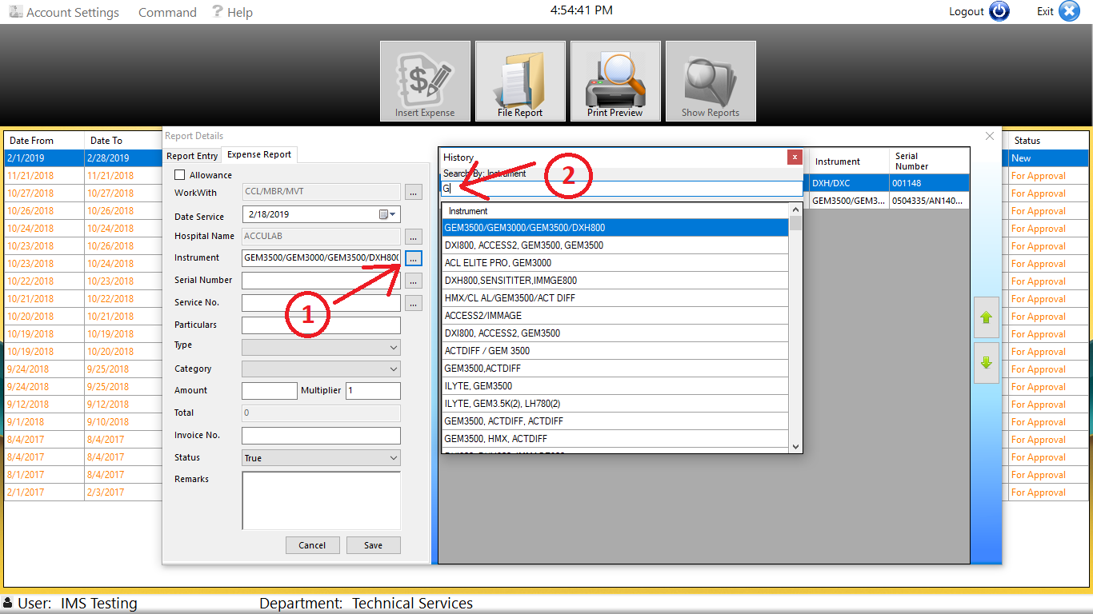

3.0

Instrument name

- To choose “Instrument” click three (3) dotted button, shown in the photo above (1), list of instrument name will pop-up

- Enter initial/instrument name and list of instrument names will show, double click to select

Note: If the instrument name that you are looking for is not included on the history, kindly enter on the corresponding textbox.
Make sure that the format is followed, if there are many instrument:
e.i. DXH800/DXC600/. . . or DXH800,DXC600,. . .

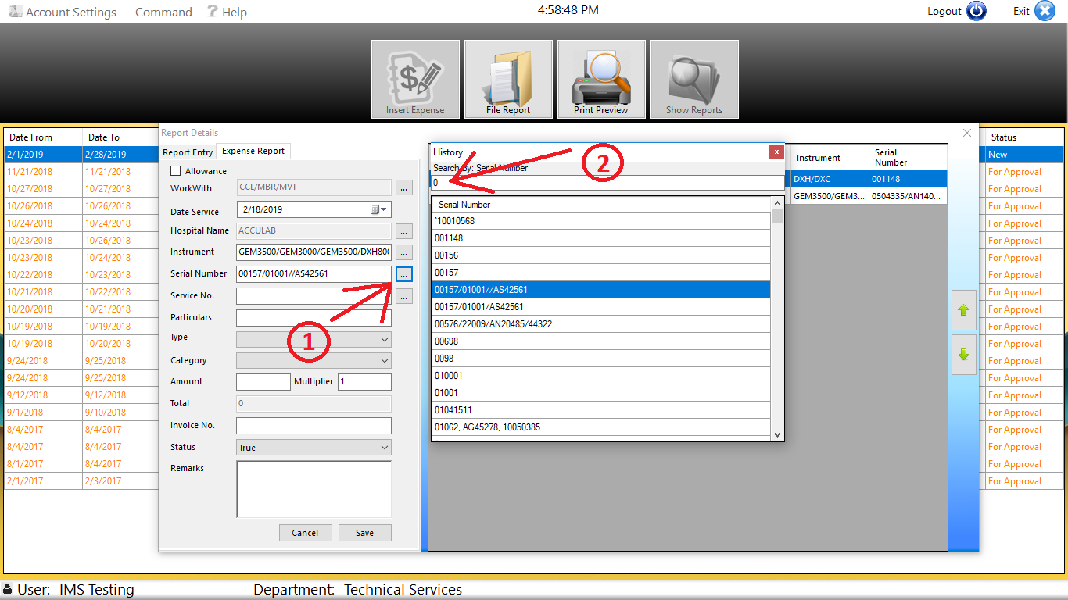

4.0

Serial Number

- To choose “Serial Number” click three (3) dotted button, shown in the photo above (1), list of serial number will pop-up

- Enter serial number and list of serial number will show, double click to select

Note: If the serial number that you are looking for is not included on the history, kindly enter on the corresponding textbox.
Make sure that the format is followed, if there are many instrument:
e.i. 123456/234567/. . . or 123456,234567,. . .

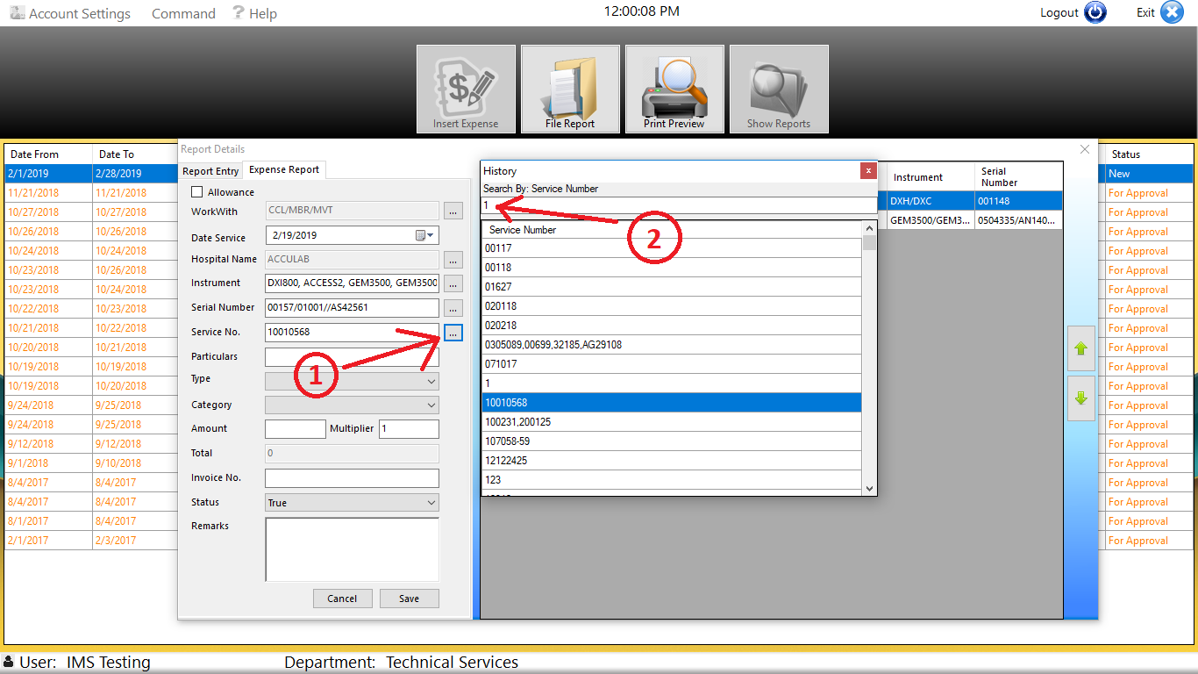

5.0

Service Number

- To choose “Service Number” click three (3) dotted button, shown in the photo above (1), list of service will pop-up

- Enter service number and list of service number will show, double click to select

Note: If the service number that you are looking for is not included on the history, kindly enter on the corresponding textbox.

